|  |  |  |  |  |  |
| --- | --- | --- | --- | --- | --- |
| Date | 2-Dec-22 | | | Tester Name | Jessie Liu |
| Environment | Select Environment | | | Login used |  |
| Operating System | Select OS | Version: | Update: | | |
| Software Used | Select Software | Version: | Update: | | |
| Select Software | Version: | Update: | | |
| Release version |  | | | | |
| Title | Enrolment | | | | |
| Test Type | Regression | | | | |
| Test Scenario |  | | | | |
|  |  | | | | |
| Expected Results | Error message showing those fields cannot be Null, unable to Save the Create File | | | | |
| Pass/Fail | Pass | | | JIRA# | N/A |

Describe your steps with screenshots:

1. Login MEPP DCT and create enrolment file

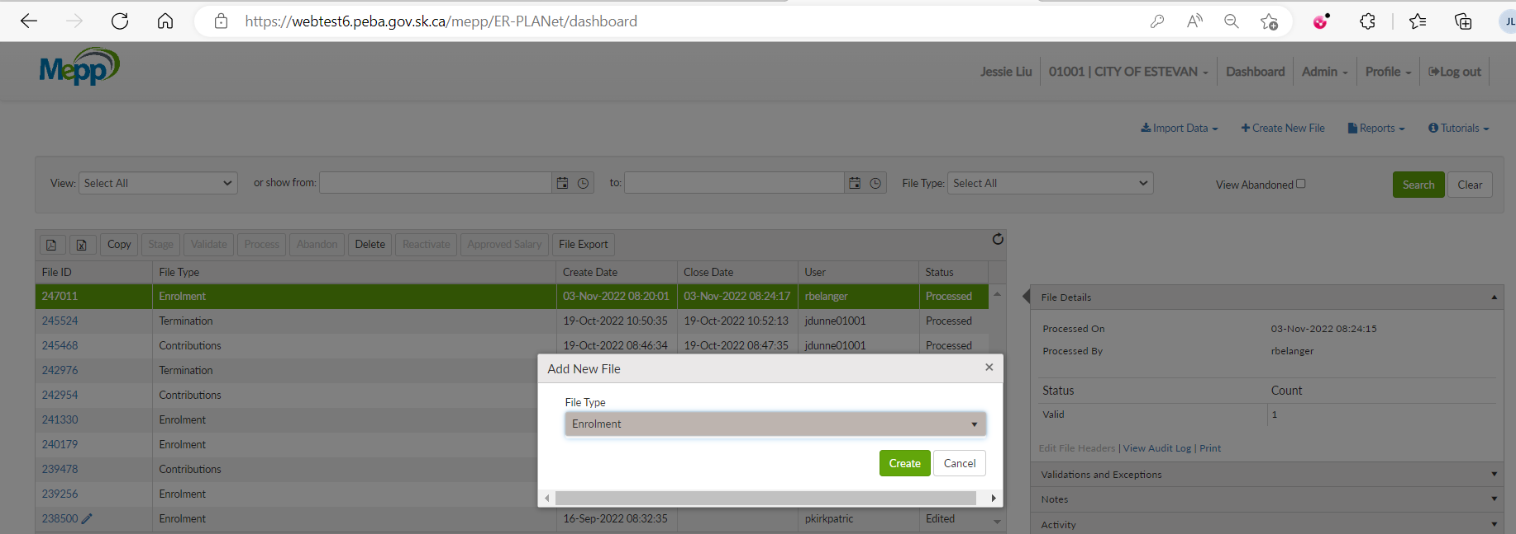

1. Fill SIN, last name, first name, and try to save the file

From the screen print below, those fields are mandatory and can’t be NULL

